WOMEN AND SPIRITUALISM WITH

REV. JACKIE RANDALL

AUGUST 18, 2019

1-3PM

$20 Members/$30 Non-members

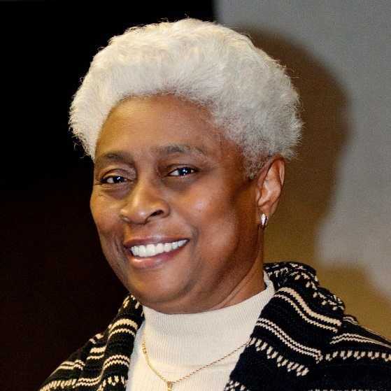

Spiritualism, Women's Suffrage, and Controversy Empowerment for women has not been an easy path. Women have moved from various arenas of deceitfulness, scheming, and historical repression to arenas where the establishment is challenged on all fronts. Heroines of yesteryear, yesterday, and today will share their plight as have been shared in history.

How can we enhance our empowerment as Spiritualist? In what way are women today bringing their empowerment to the forefront? Can Spiritualism move forward with a revival of similar methods used throughout the new dispensation?

Albertson Memorial Church 293 Sound Beach Ave, Old Greenwich Phone: (203) 637-4615 Email: info@albertsonchurch.org Website: www.albertsonchurch.org

