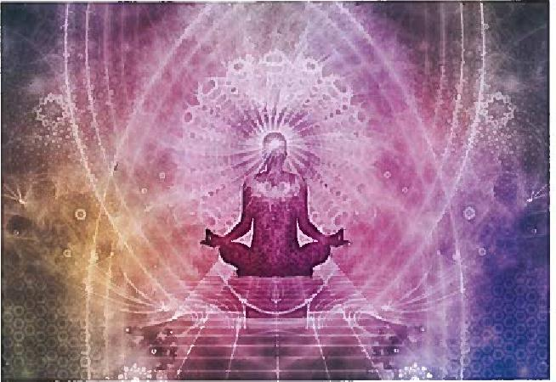

Beginner’s Mediumship and Psychic Development Workshop

Interested in exploring and developing your psychic and mediumistic abilities? Join us for this fun, interactive workshop series that offers interesting discussions, lectures and exercises in a supportive environment. You will have opportunities to hone your skills as you practice providing evidential psychic and mediumistic readings that are meaningful and healing.

Wednesday Nights 7:00

Albertson Memorial Church
Old Greenwich CT

$20.00 Per Class

