JUNE 23, 2019 SUNDAY SERVICE 11:00 AM - 12:30 PM with Rev. Robin Dubord
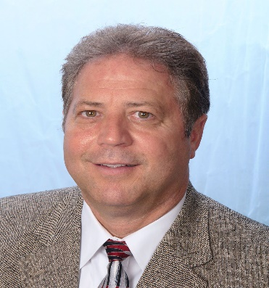
Rev. Robin Dubord is a member of the First Spiritualist Church of Willimantic. He is a Certified Medium, a Commissioned Healer and a National Spiritualist Teacher with the NSAC. Robin has had the privilege to serve many Spiritualist churches throughout New England, for over 20 years.
In addition to teaching classes and workshops on mediumship, psychic development, healing and Natural Laws, he is also known as a speaker, healer, and medium sharing the knowledge of Spiritualism and the Natural Laws of God.
How to Develop and Improve Your Mediumship 1:00-3:00 PM $25 Members/$35 Non-Members This workshop will help you understand how to develop and increase your ability to communicate with those in spirit. The basic foundation that is needed to develop mediumship will be explained and examples examined. All those attending will also be shown and participate in several exercises to develop, strengthen, and grow your connections with spirit. All levels of understanding are encouraged to attend. Everyone will get messages.

