SUNDAY, JUNE 2, 2019, 1-2 PM

TRADITIONAL

CELTIC HARP CONCERT

WITH REMY DEVERE

$15 Members / $20 Non-Members

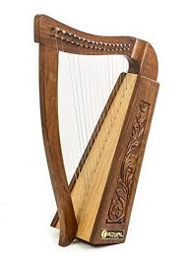

Albertson Memorial Church
293 Sound Beach Ave, Old Greenwich
Phone: (203) 637-4615
Email: info@albertsonchurch.org
Website: www.albertsonchurch.org

