SUNDAY, OCTOBER 27, 2019

1-3 PM

$45 Members/$50 Non-Members

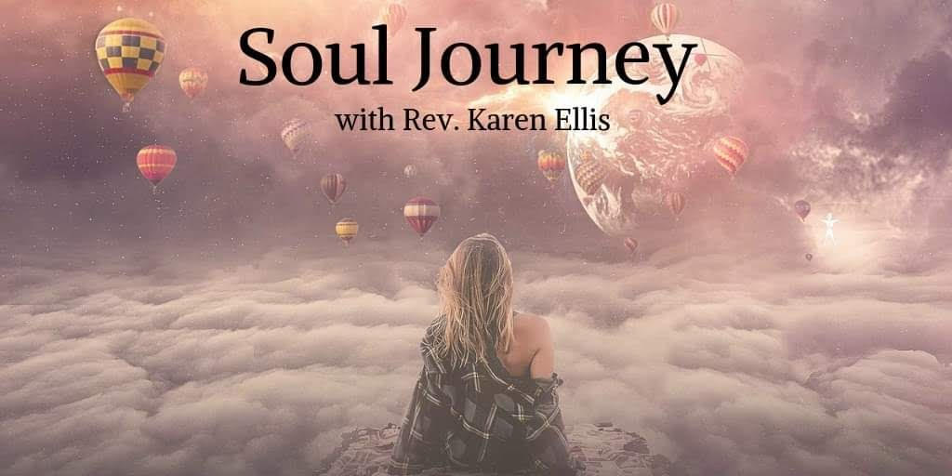
Come and celebrate your journey. Let's recognize the AHA moments embraced by your soul and identify the significant events of your journey. You will be guided to create a timeline from birth to the present mapping events that changed and elevated your path. We will use the power of images and words by creating a visual to activate the Law of Attraction and with the power of spirit, create and manifest a path of joy and continued growth.
Please bring a photo of yourself. Magazines and other materials will be provided but feel free to bring any photos or images of places, people or goals that make your soul sing!

Albertson Memorial Church
293 Sound Beach Ave, Old Greenwich
Phone: (203) 637-4615
Email: info@albertsonchurch.org
Website: www.albertsonchurch.org

