OCTOBER 6, 2019 1:00 PM - 3:00 PM $20 Members/$30 Non-Members

YOUR ROLE WITH ANIMAL COMPANIONS: WHO CHOOSES WHO?

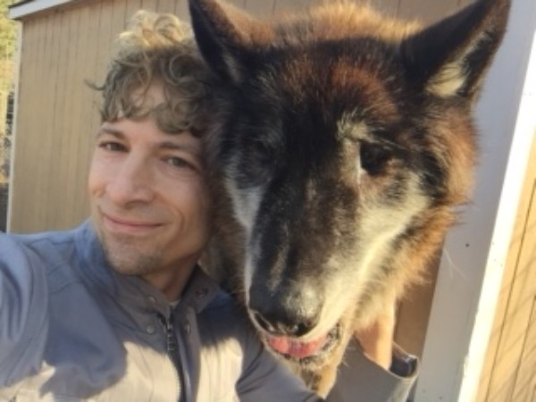

CHRIS DESERIO, MA,CHt

Trance Medium, Healer and Animal Communicator
This workshop looks to better define your connection with animals. What’s the surface lesson
followed by the deeper meaning to the dynamics of each relationship, be it with those domesticated
or out in the wild? Why is it that you’re attracted in such a way to those particularly in the animal
kingdom and vice versa? What’s 1 or more of your totem animals? What do they represent in terms
of guidance and other help being offered in the now and how does their presence demonstrate how
far you’ve come thus far? These questions and more will be explored through a highly participatory
environment in which exercises will be conducted and group discussion of thoughts and findings
encouraged.

Your tutor, Chris DeSerio, is a metaphysician practicing professionally for over 20 years as a medium, healer, medical intuitive, psychic, and paranormal investigator coupled with being an animal lover all his life.

Albertson Memorial Church
293 Sound Beach Ave, Old Greenwich
Phone: (203) 637-4615
Email: info@albertsonchurch.org
Website: www.albertsonchurch.org

